

**PROJECT PLAN**

**Project name:** Solar energy calculator

**Group number:** 2

**Date:** 2016-12-04

**Course:** Software Engineering 2: Project Teamwork (DVA313)

**Academy:** Innovation, design and technology

**Index**

1. Introduction 2

2. Project Organization 2

2.1 Project group 2

2.2 Organization and communication 3

2.3 Planned effort per member for each week in the project 3

2.4 Deliverables, deadlines, milestones and activities 3

2.4.1 External 4

2.4.2 Internal 5

2.5 Quality assurance 6

3. Description of the system to be developed 6

3.1 High-level description of the domain and the problem 6

3.2 Description of the existing systems 7

3.3 High-level description of the desired functionality 7

4. Initial project backlog 9

# 1. Introduction

We are going to do a project for the client named Bengt Stridh, from the Future Energy Center research specialization at Mälardalen University. The client and his colleagues have in a previous project, developed detailed models that are used to analyze investment decisions for photovoltaic (PV) plants in Sweden. Our task in this project is to develop a web-based tool to support different stakeholders, such as private persons and companies. The users should in a straightforward fashion be able to determine what investments in solar energy that are suitable for them, based on a number of default input parameters that can be adjusted by the users. The photovoltaic market has been growing strongly during the last years. However, the general knowledge of PV among potential investors is still low, and therefore they could miss out on for example financial and environmental benefits. Because of this there is a strong need for a user-friendly tool, to make it easier to calculate both production cost and profitability for PV investments in Sweden (i.e. the users should know what input to insert to suit their personal needs). Furthermore, this new web-based tool will hopefully benefit from the dynamical nature of web applications, which could enable a more user-friendly environment and also make the photovoltaic investment calculator accessible for a larger audience.

# 2. Project Organization

Here you can read about the project group, organization, communication, planned effort per member for each week in the project, deliverables, deadlines, milestones, activities and quality assurance.

## 2.1 Project group

In Table 1 below, you can find information (i.e. name, email, roles and responsibilities) about all of the project members. The roles or responsibilities might change during the project, for example if a person is more suitable for a particular role or responsibility. All of the project members will also help out the other project members with their roles or responsibilities if necessary.

|  |  |  |
| --- | --- | --- |
| **Name** | **Email** | **Roles/Responsibilities** |
| Lukas Hamacek | lhamacek@outlook.de | Project manager |
| Aliya Hussain | syeda.aliya.hussain@gmail.com | Documentation and presentation |
| Charlie Höglund | c.hoglund@live.se | Trello manager |
| Jonathan Larsson | jonathan-larsson@outlook.com | Configuration manager (SVN/GitHub) |
| Sebastian Lindgren | sebbestune@icloud.com | Client contact |
| Avalika Podduturu Reddy | avalika12@gmail.com | Report overseer and designer |

**Table 1 –** Information about all of the project members.

## 2.2 Organization and communication

Every Monday during this course we will have a project meeting with the external steering group in the university’s facilities. In addition to that we will have at least one internal project meeting per week, either physically in the university’s facilities or non-physically over for example the communication service called Slack. We will also make sure to have a small internal project meeting before the meeting with the external steering group on Mondays, which will allow us to go through all of the material to be presented to the steering group. The number of internal project meetings may differ from week to week depending on whether we actually need more meetings or not. We aim to have one client meeting or contact every week as well. As mentioned before the forms of contact will either be physical (i.e. in the university’s facilities) or non-physical (i.e. over communication services like Slack or email). We will also use the collaboration tool called Trello, to follow the progress of the current week’s activities and plan activities for the upcoming week. When using Trello, you get a graphical board which allows you to see what activities that are available, what activities that are being worked on, what activities that have been finished, who is working on what activities, and how much time effort that has been used for the activities. Each project member will report their own worked hours per week by entering the necessary data in an Excel file (i.e. a specific file for each project member) available on the GitHub repository. All of the results such as documentation and code will be reported by committing/uploading them to the GitHub repository, which allows both the project members and the steering group to access them. All of the project members will be able to commit results to the GitHub repository, but sometimes it might be required to have internal discussions with some particular project members before merging for example your code with theirs.

## 2.3 Planned effort per member for each week in the project

This project course is on 7.5 hp and 50% pace, which corresponds to approximately 20 work hours per week for each project member. Then there is approximately a total of 8 work weeks, since there will be a few days of absence among the project members during the Christmas holidays, the last week of the course will not be a full week etcetera. Therefore, each project member should have a total effort of approximately 160 hours in the end (i.e. 20 hours * 8 weeks = 160 hours). However, the project members may choose for themselves how to divide their total of 160 hours throughout the weeks as long as the internal and external deadlines are fulfilled.

## 2.4 Deliverables, deadlines, milestones and activities

Here you can find external and internal deliverables, deadlines, milestones and activities in the project. You can also see when they are planned and how much effort that they might require.

### 2.4.1 External

In Table 2 you can see the external deliverables, and in Table 3 you can see the external project meetings and presentations.

|  |  |  |
| --- | --- | --- |
| **Deliverable** | **Deadline** | **Total effort in hours** |
| Project plan | Nov 17 | 35 |
| Design description (1st version) | Dec 1 | 30 |
| Product (1st version) | Dec 1 | 100 |
| Design description (final version) | Jan 12 | 60 |
| Product (final version) | Jan 12 | 200 |
| Final project report | Jan 12 | 200 |

**Table 2 –** The external deliverables with their deadlines and total time efforts.

|  |
| --- |
| **Meetings with the steering group (25 min effort each, total effort: ~3 hours/member):**  Project meeting - Nov 9  Project meeting - Nov 14  Project meeting - Nov 21  Project meeting - Nov 28  Project meeting - Dec 5  Project meeting - Dec 12  Project meeting - Dec 19  **Presentations (2 h 45 min effort each, total effort: ~8,25 hours/member):**  Project plan and requirements - Nov 23  Preliminary design and implementation - Dec 7  Final presentation - Jan 11 |

**Table 3 –** The external project meetings and presentations with their planned dates and time efforts/member.

### 2.4.2 Internal

In Table 4, 5 and 6 you can see some of the internal activities in the project.

|  |  |  |
| --- | --- | --- |
| **Activity** | **Deadline** | **Total effort in hours** |
| Learn how to use GitHub/Git (i.e. the project members who need it) | Nov 16 | 10 |
| Learn how to use Trello | Nov 16 | 15 |
| Build and present a lightweight website layout for the client | Nov 22 | 30 |
| Learn/relearn the necessary web skills (e.g. php, ajax, javascript etc.) | Nov 28 | 120 |

**Table 4 –** The internally general activities with their deadlines and time efforts.

|  |  |  |
| --- | --- | --- |
| **Activity** | **Deadline** | **Total effort in hours** |
| Review of the project plan | Nov 17 | 6 |
| Review of the design description (1st version) | Dec 1 | 6 |
| User test of the 1st product version | Dec 1 | 6 |
| Review of the product (1st version) | Dec 1 | 6 |
| Review of the design description (final version) | Jan 12 | 10 |
| User test of the final product version | Jan 12 | 10 |
| Review of the product (final version) | Jan 12 | 15 |
| Review of the final project report | Jan 12 | 15 |

**Table 5 –** The internal review activities with their deadlines and time efforts.

|  |  |  |
| --- | --- | --- |
| **Activity** | **Deadline** | **Total effort in hours** |
| Prepare for the “project plan and requirements” presentation | Nov 23 | 15 |
| Prepare for the “preliminary design and implementation” presentation | Dec 7 | 15 |
| Prepare for the “final presentation” | Jan 11 | 20 |

**Table 6 –** The internal preparation activities with their deadlines and time efforts.

## 2.5 Quality assurance

Firstly, we have the quality assurance of the documentation deliverables such as the project plan, design description, final project report and so on. Before reporting the specific documentation deliverable, we plan to have an activity where at least one project member reads through the documentation again while looking for grammatical, layout or logical mistakes etcetera. Secondly we have the quality assurance of the implementation deliverables such as the finished code and graphical user interface (i.e. the final product). To make sure that the graphical user interface is for example user-friendly, then we can let both the client and other external people (e.g. students on the school) do a user test, where they can try it out and share valuable feedback. To assure the quality of the different units (i.e. functionalities/features) of the system we will start with doing unit testing, which will be done as soon as each unit is implemented. Then we will do an integration test to assure that all of the different units of the system works together as expected. Finally, we will test the complete system by letting both the client and other external people try it out, which will allow us to see if the system works as expected in a real life scenario.

# 3. Description of the system to be developed

Here you can read about the high-level description of the domain, the problem, description of the existing systems, and high-level description of the desired functionalities.

## 3.1 High-level description of the domain and the problem

A preliminary specification has been provided by the client. The purpose of the calculator is simply to calculate both the production cost and profitability for photovoltaic installations in Sweden. Its intended users are both private persons and other users (e.g. companies, property owners and cities). The problem is that very few users have enough knowledge about photovoltaics, and that there are a lot of necessary parameters to be inputted for the calculations (i.e. the users do not really know what inputs that are suitable for them). However, the solution for this problem is to provide default input parameters (i.e. different for private and other persons regarding for example taxes), recommended minimum and maximum values, guiding texts etcetera.

## 3.2 Description of the existing systems

The system that is currently being used is in the form of an Excel file (i.e. one each for both private persons and others which have the same calculations but different default input parameters), in which the user has to enter the necessary input parameters inside cells and then some built-in functions calculate the results (i.e. the results are presented as numbers, tables and diagrams). The Excel files are available online at Mälardalen University’s webpage (link: <http://www.mdh.se/forskning/inriktningar/framtidens-energi/investeringskalkyl-for-solceller-1.88119>). Our own web application will at least have the same functionalities as the ones in this already existing system, but bring it to the web. In other words, the already existing system will not be extended, but instead give us knowledge about the functional basis on which our web application will be built upon.

## 3.3 High-level description of the desired functionality

The client has provided a specification with requirements (i.e. functionalities) that are a must to implement, and also requirements that are not a must to implement unless there is time to do it. Here are the following requirements:

**Requirements that are a must to implement:**

* Possibility to choose between private person and other user
* Provide guiding texts and recommended minimumand maximumfor input values
* Calculate the production cost, profitability and cash flow
* Provide diagramsthat show some of the calculated results
* A printable PDF file containing both input and output values
* Possibility to upload an Excel file for updating the default input values, guiding texts, minimum and maximum values

**Requirements that are not a must to implement:**

* Compare the calculated results for two sets of input values
* Save used input values from one session to a session at a later time
* Switch between English and Swedish language

In Figure 1, we have visualized all of the desired requirements through a use-case diagram. Notice that it also for example contains a possibility to create an account. The reason why we have added this, is because the user should be able to have an account to access previously saved used input values (i.e. restore input values from an earlier session) and calculated results (i.e. for comparison of two results) in a database.

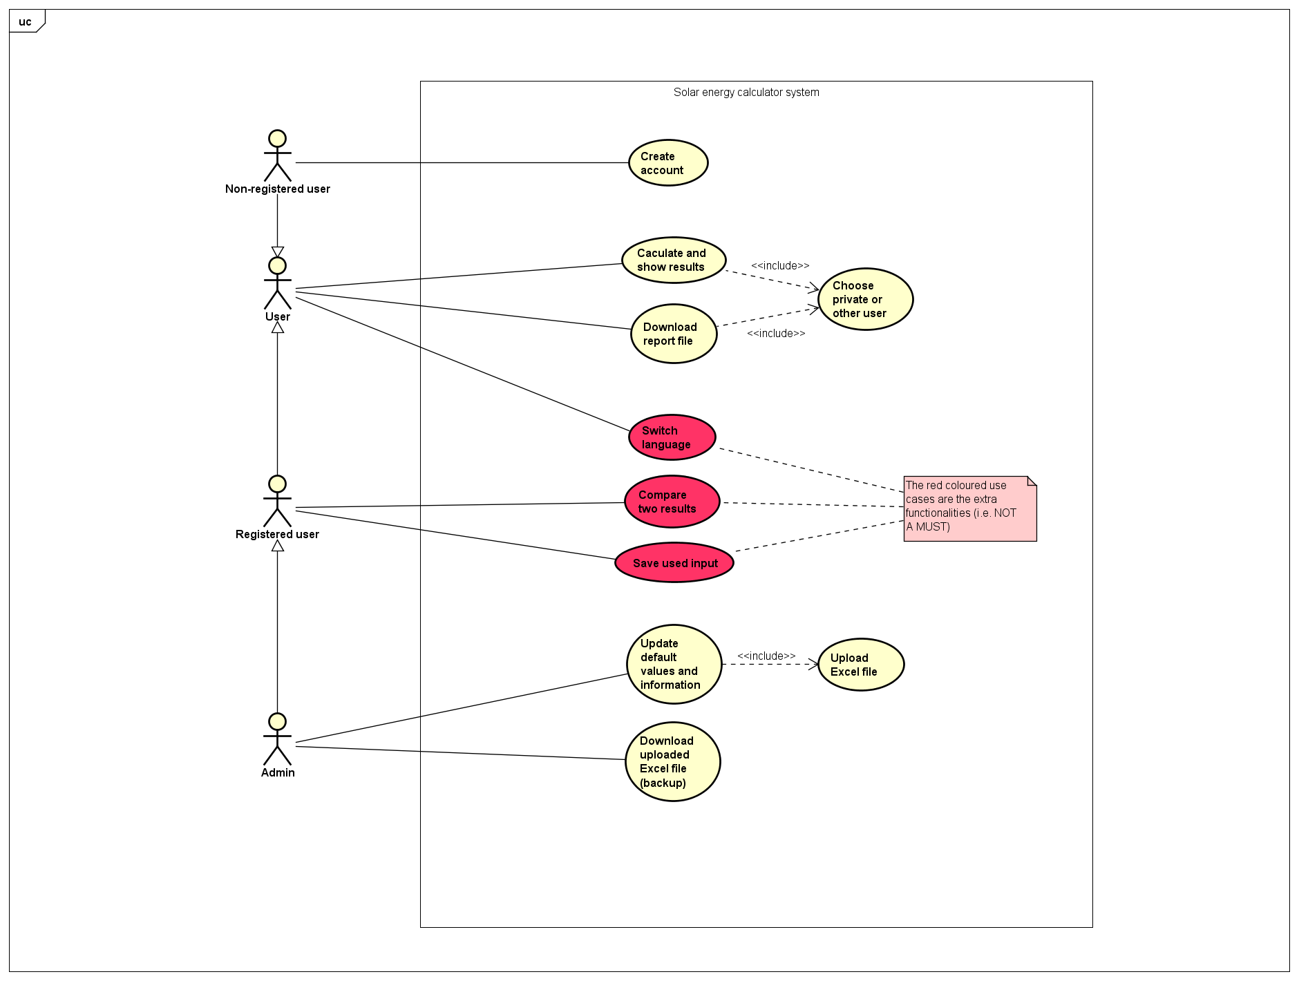

**Figure 1-** This is a use-case diagram that captures the desired functionality. Notice the red use-cases which are not a must to implement (i.e. extra functionalities).

# 4. Initial project backlog

In the following table you can see our initial project backlog. Each entry in the backlog has been given an id, description, importance (i.e. the higher it is, the more important it is to finish) and approximate effort in person-hours.

|  |  |  |  |
| --- | --- | --- | --- |
| **ID** | **Description** | **Importance** | **Effort (in hours)** |
| 1 | As a user I want to be able to choose between private person and other user, so that it can affect my default input values | 100 | 15 |
| 2 | As a user I want to be able to see guiding texts, recommended minimum and maximum input values, so that I know what to input | 100 | 10 |
| 3 | As a user I want to be able to calculate production cost, profitability and cash flow to know what investments to make in photovoltaic installations | 100 | 60 |
| 4 | As a user I want to be provided with diagrams that show calculated results, so that I know what investments to make in photovoltaic installations | 100 | 10 |
| 5 | As a user I want to be able to get a printable PDF file containing both input and output values, so that I can use it for different purposes (e.g. show it on meetings) | 100 | 15 |
| 6 | As an administrator I want to be able to upload an Excel file for updating the default input values, guiding texts, minimum and maximum values, so that the users can use them | 100 | 15 |
| 7 | Database | 100 | 25 |
| 8 | Server | 100 | 20 |
| 9 | User-friendly design and layout | 100 | 30 |
| 10 | As an administrator I want to be able to download an uploaded Excel file, so that I can retrieve it if I lose the original file | 80 | 5 |
| 11 | As a user I want to be able to create an account so that I can access saved data (e.g. used input values from an earlier session) in the database | 80 | 10 |
| 12 | As a user I want to be able to compare two calculated results, so that I can make a good investment in photovoltaic installations | 70 | 15 |
| 13 | As a user I want to be able to save used input values from an earlier session, to be able to use it at a later session | 60 | 10 |
| 14 | As a user I want to be able to switch language, so that I can understand what it says on the website | 50 | 8 |